**AWS Concepts**

# A Conceptual Introduction to Amazon Web Services (AWS)

## AWS & the Cloud

Understanding AWS

What is the cloud ?

It’s just a computer that’s somewhere else, in reality it’s not just one single computer but it’s a data center, rows of server computers.

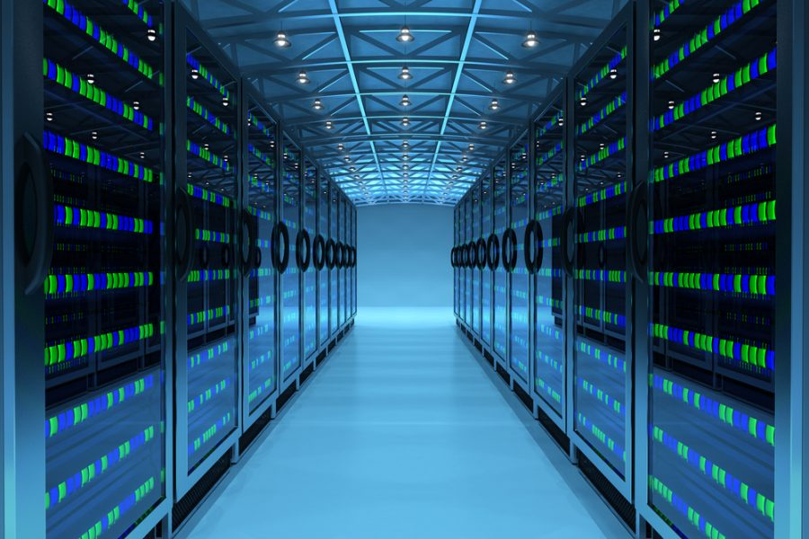

Amazon Web Services is a Cloud services provider

We use Cloud services like ICloud or DropBox for backups or share or files

What is important in the Cloud is : High availability and Fault tolerant

High availability means that if you put a file into the cloud you can access it from any type of device or any type of computer and from anywhere as long as it has an internet connection.

Fault tolerant means that teh files is up in the cloud and it’s backed up on multiple services and if the cloud server fail there will always another copy on another server.

On-premise : Is when a company is not using cloud services and store their data on their own server computers.

Imagine a company with 1000 users which takes three servers to power the software for those 1000 users.

If in 2017 this company estimate that they will growth and have 5000 users, than they’re going to add servers computers to handle the load of having more users.

Mais pour faire cela il leur faudra de la place pour mettre 3 nouveaux serveurs, savoir quel type de serveurs il faut, les acheter, les installer avec tous les logiciels nécessaires.

Imagine qu’en 2018 ils estiment avoir 20 000 users de plus, ils devront donc ajouter 12 serveurs, mais si au final ils n’ont que 7000 users ils auront donc des serveurs en trop.

The same thing but with AWS

If the company grows from 1000 to 4000, AWS can automatically add additionnal servers so the company did not have to estimate the growth, make sure they have room on their on-premise data center, figure out what kind of servers they nedd, buy them, wait for the delivery and install them, install OS and softwares.

So process that used to take several weeks can now be done in a matter of minutes with cloud service provider.

Si finalement les users baissent à 3000, automatiquement un serveur par exemple sera supprimé, ainsi tune paies que pour ce que tu utilises.

Scalability : It’s the ability to quickly and easily add more servers as needed.

Elasticity : You can add or shrink

# Introduction to Core AWS Services

## Understanding VPCs

**AWS architecture**

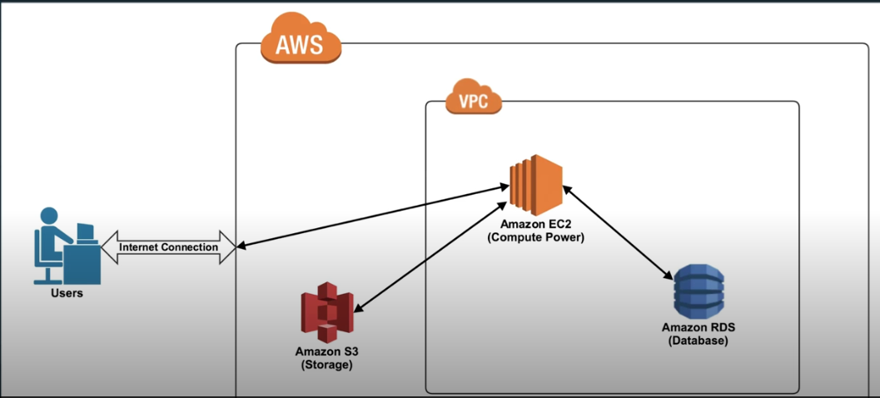

VPC = Virtual Private Cloud

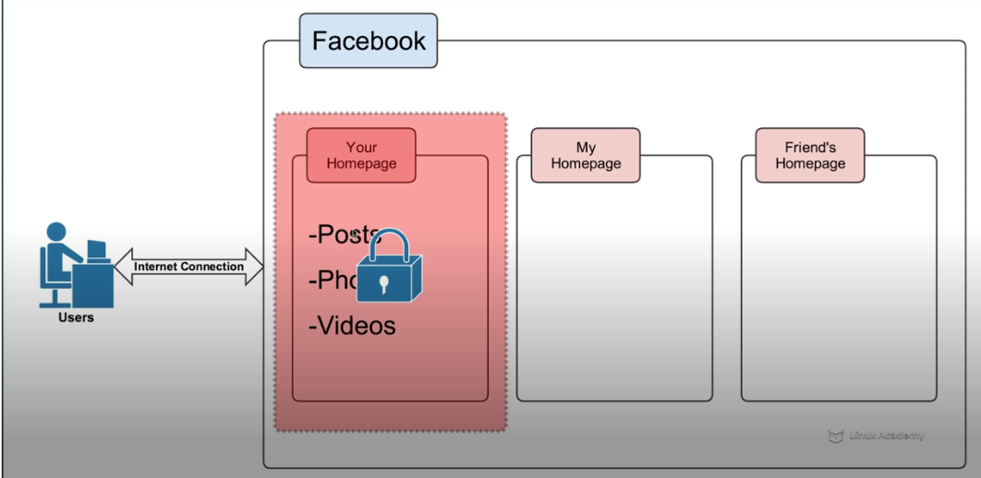

Exemple avec Facebook, tu as accès à Facebook sur ta page privée, tu peux décider de qui peut la voir ou pas, y poster des choses etc. Idem pour chaque personne ayant une page Facebook.

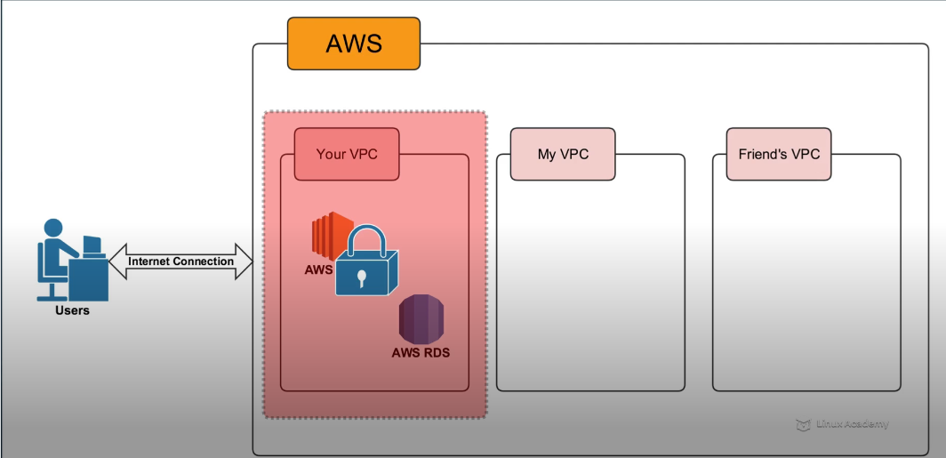

VPC is your private section of AWS where you can put your own resources in and either allow or restrict access

## Understanding EC2

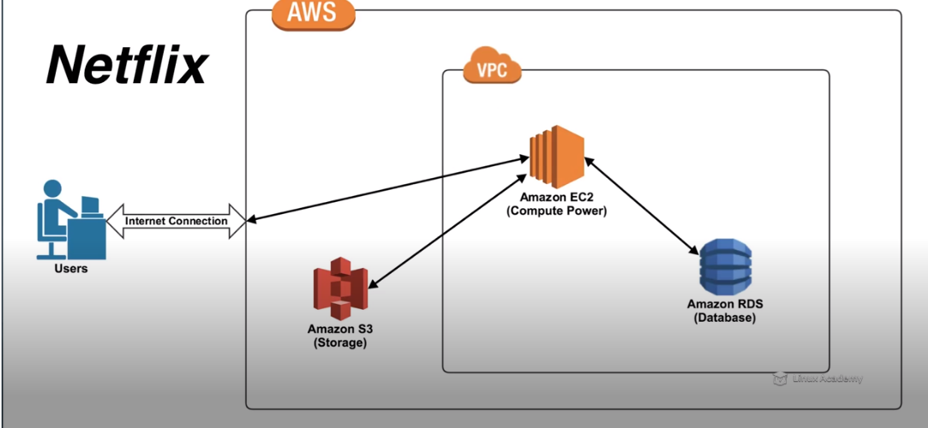

EC2 means Elastic Cloud Compute, it’s the virtual equivalent of a computer ou plutôt un serveur virtuel.

We also say an instance.

When you go to [www.netflix.com](http://www.netflix.com) you are connecting to an Amazon EC2 instance which is currently serving as a web hosting server.

**Scalability:**

One server can handle a certain amount of traffic, so if there’s too many users trying to hit just one server, that server is going to crash. Scalability means that Aws will automatically add another EC2 instance.

**Elasticity:**

If the numbers of users drop off, AWS will automatically remove one or more servers

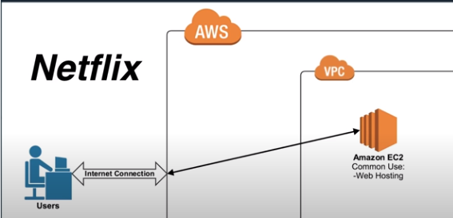

## Understanding RDS

Is a database platform provided by Amazon Web Services.

Common use:

* Customer Account info
* Inventory Catalog

## Understanding S3

Common Use:

* Mass Storage
* Long-Term Storage

S3 means Simple Storage Service, is the storage platform of AWS, it’s a large storage bucket.

For example, Netflix stores their video files in S3.

In S3 you can store documents, files video, etc.

Dropbox uses S3, so when you use Dropbox you are actually putting your file into Amazon S3 Bucket

S3 has a load of redundancies

# AWS Global Infrastructure

## Understanding How AWS is Physically Set Up

On 25/03/2020:

AWS now spans 69 Availability Zones within 22 geographic regions around the world, and has announced plans for sixteen more Availability Zones and five more AWS Regions in Indonesia, Italy, Japan, South Africa, and Spain.

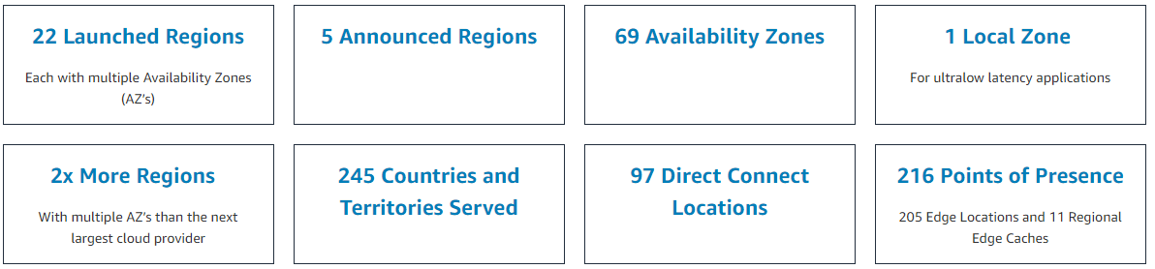

Amazon World Map

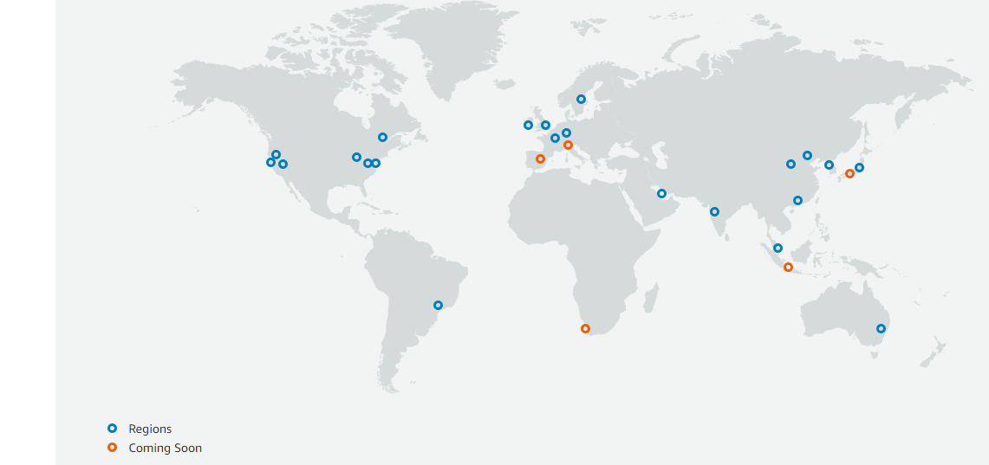

Each region has a set of Availability Zones and each one of these Availability Zones is geographically separated from the other. So if this is the North Virginia region. There is an Availability Zone with a data center somewhere in North Virginia and then some miles away, whether it's 20 miles, 50 miles, 100 miles somewhere else in that region of the country, there is another Availability Zone. And in most cases, and there's also a third and sometimes a fourth Availability Zone.

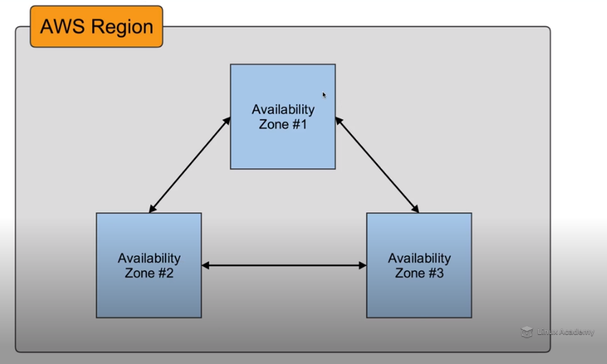

Each one of these Availability Zones contains a data center

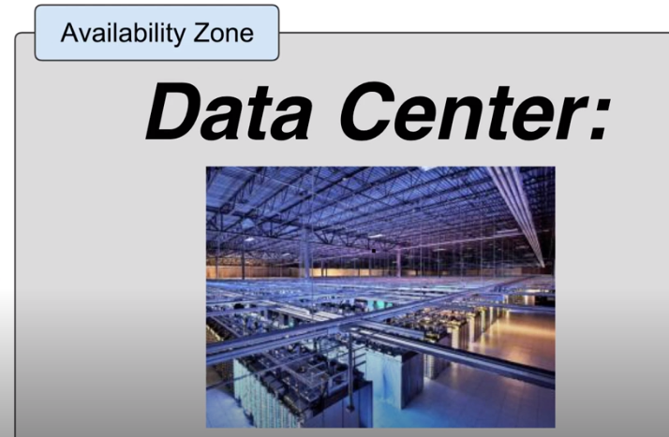

In the Data center you have Amazon EC2, S3, RDS, etc.